Lab 9: Brandon Kowal, Bernard Owusu Sefah

**Working with Multiplexers**

Abstract

The lab works with multiplexers. Using 1-bit 8x1 multiplexers a 2-bit 8x1 source selector can be made. WinLogiLab will be used to design and test the created circuit. The circuit used in the lab will use 2 74151 1-bit 8x1 multiplexer ICs.

Introduction

This lab is to develop a circuit that helps us understand how a multiplexer works. It will improve skill in combinational logic building blocks in digital logic design and using WinLogiLab to simulate and design.

Methods

1.We constructed an 8x1 mux using all-AND gate and checked it validity through winlogiLab.

2. We then tested our design on the ETS-7000 in the lab by using the 74151 IC we were given.

3. Finally we checked the validity of the full circuit by pushing the right switches to produce the correct corresponding output which was connected to Led indicators.

Results

Fig 1&2 showing outputted results and a carry of the mux

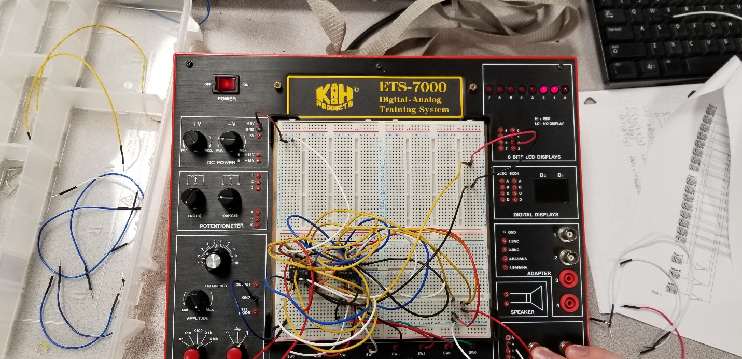

Fig 2

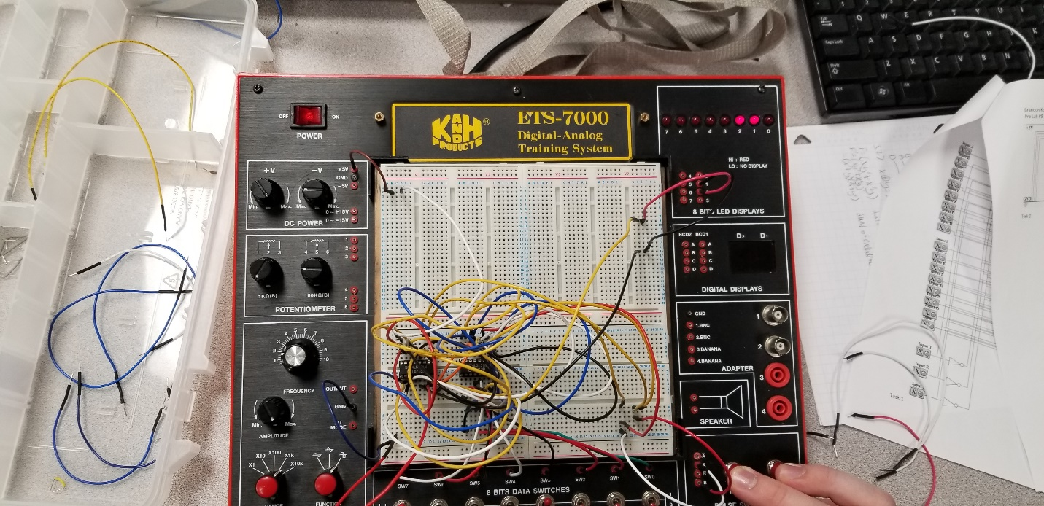

Fig 3&4 showing single output.

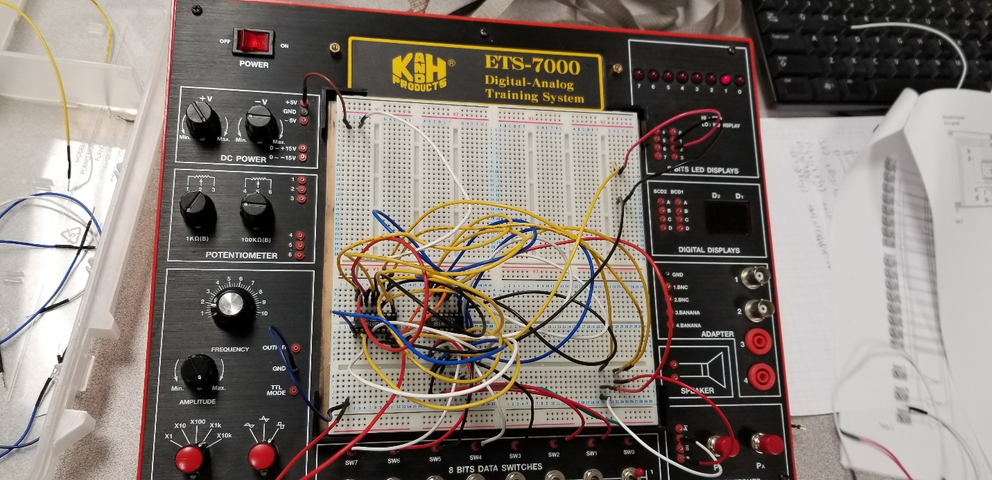

Fig 4

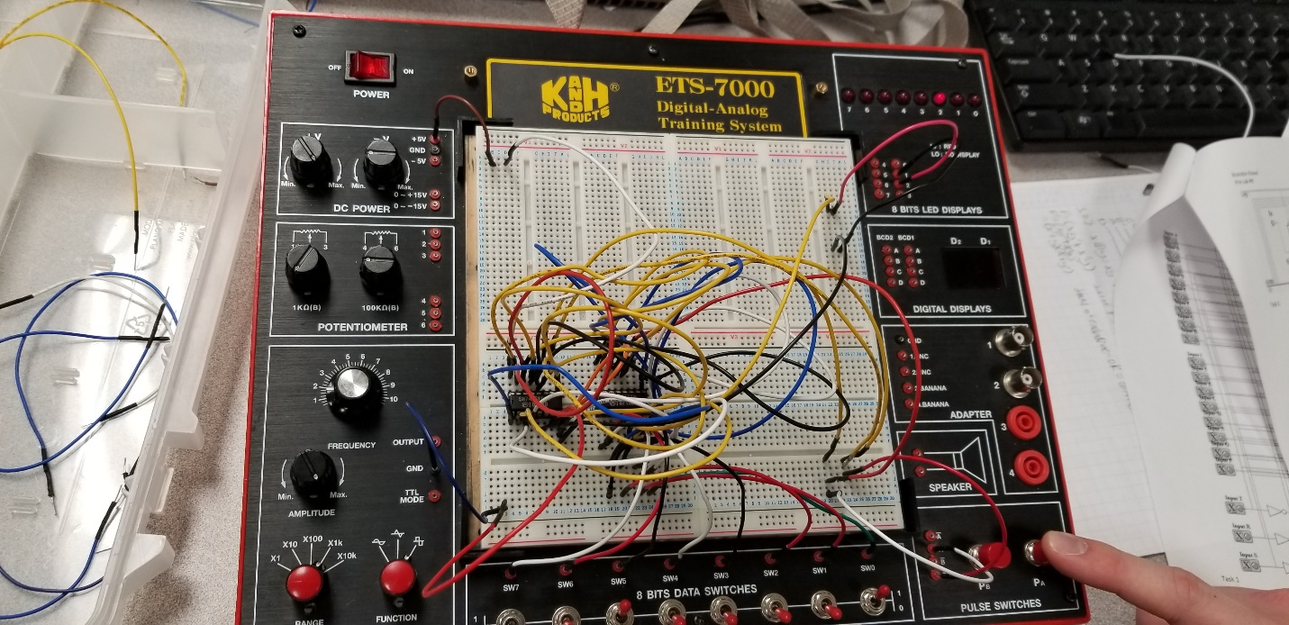

Discussion

In the lab we were able to successfully make a 2-bit 8x1 source selection logic circuit. In the lab we had to start wiring our circuit schematic because we were short of the 74151 ICs, so we had to wait for other groups to finish before we could make the second half of the circuit.

Conclusion

In this lab we designed a multiplexer circuit that was a 2-bit 8x1 source selection logic circuit. I was designed by using 1-bit 8x1 multiplexers. The 2-bit 8x1 was successfully made and out-putted the correct output lights with the corresponding switches.

Appendix

Lab Attendance: Bernard Owusu Sefah: Yes     Brandon Kowal: Yes

Involvement in Lab:  Bernard Owusu Sefah:  55 Brandon Kowal: 45

Involvement in Lab Report:     Bernard Owusu Sefah:   50 Brandon Kowal: 50